**Technical report 1.**

This is a real project given me to practice the code in HTML, CSS and JavaScript. This project is to create a progress bar for Goal Savings account in App. My senior developer give me to practice the codes for future projects.

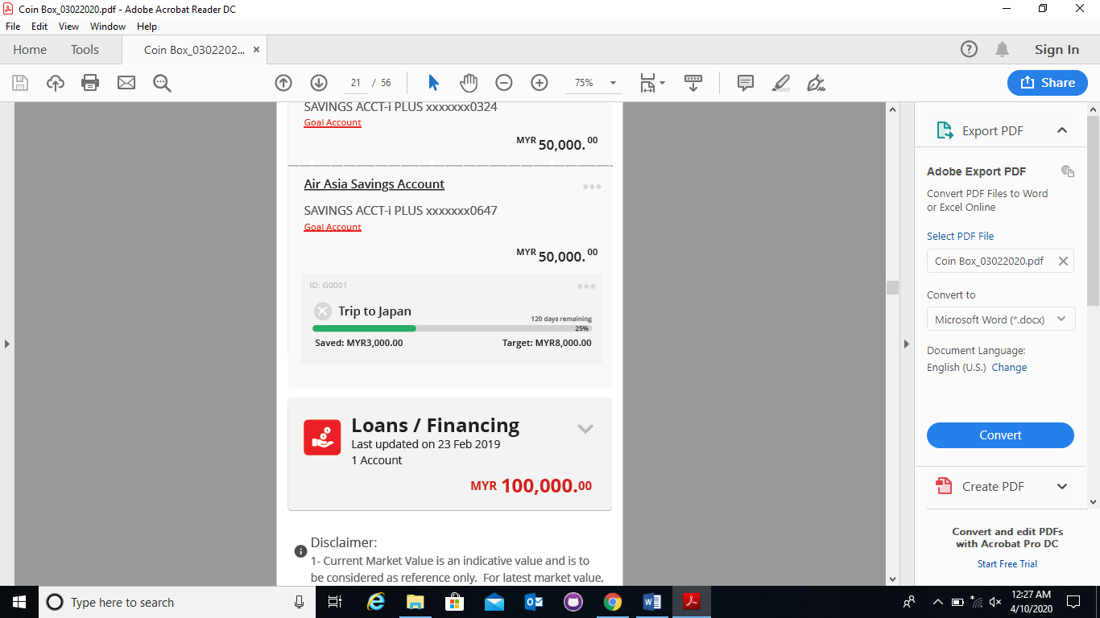

Step 1: View the pdf UI and skecth the Container and elements for further understandings.

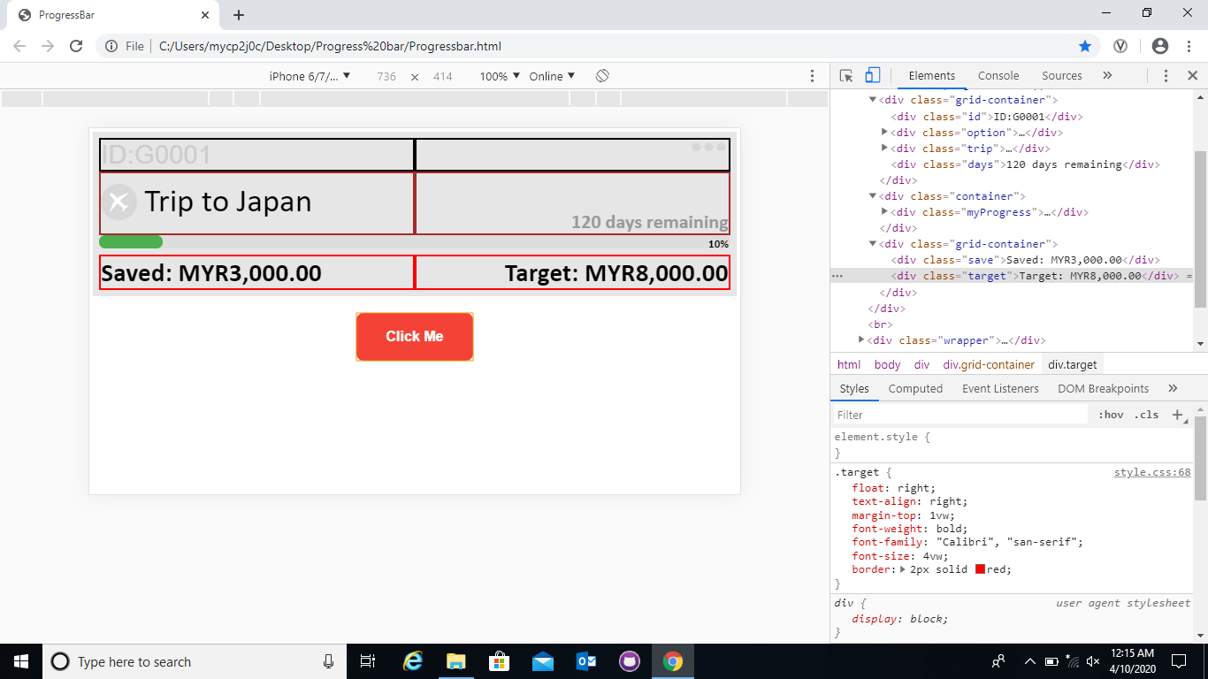

Step 2: Create container by using width size for every element and differentiate it with colors for sure about the width size and position.

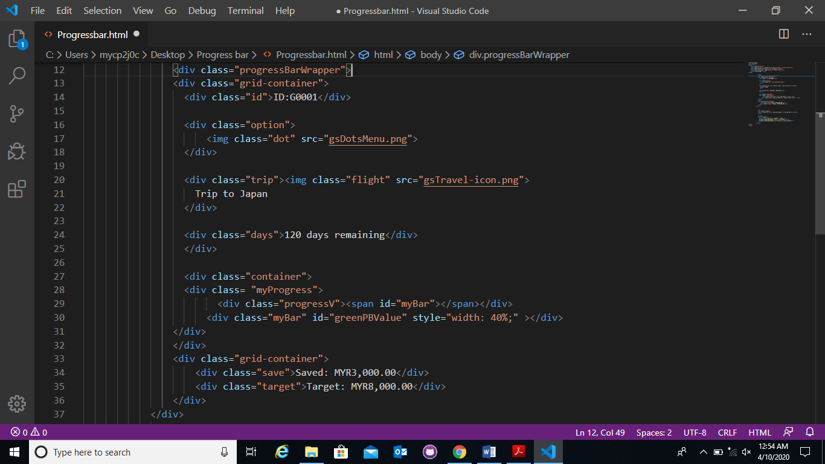

Step 3: Start Code for the elements in HTML and CSS using Visual Studio Code platform.

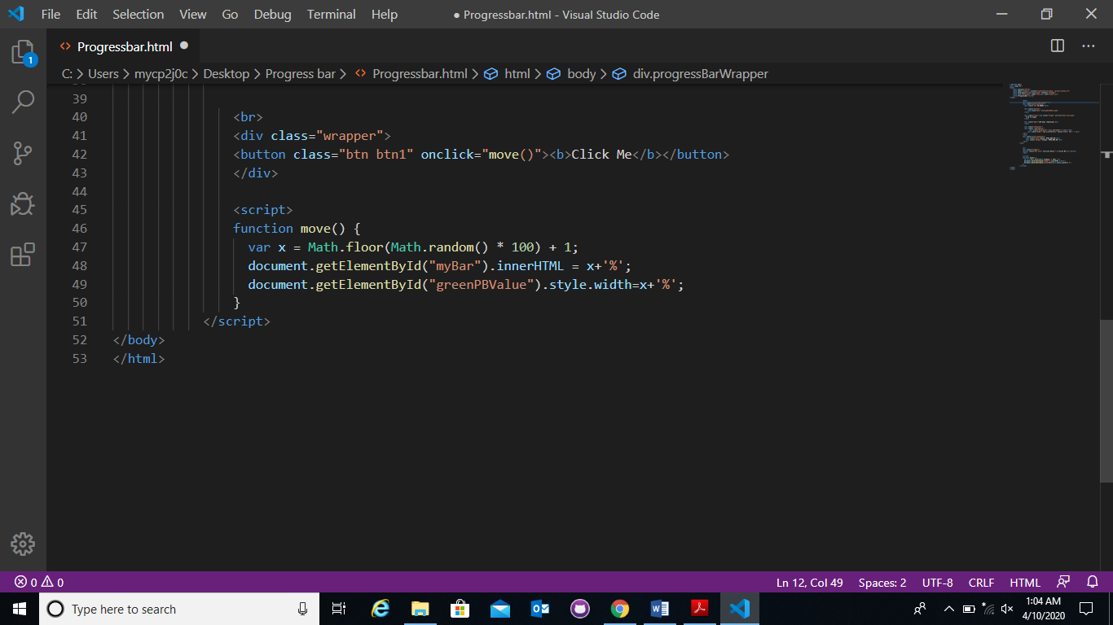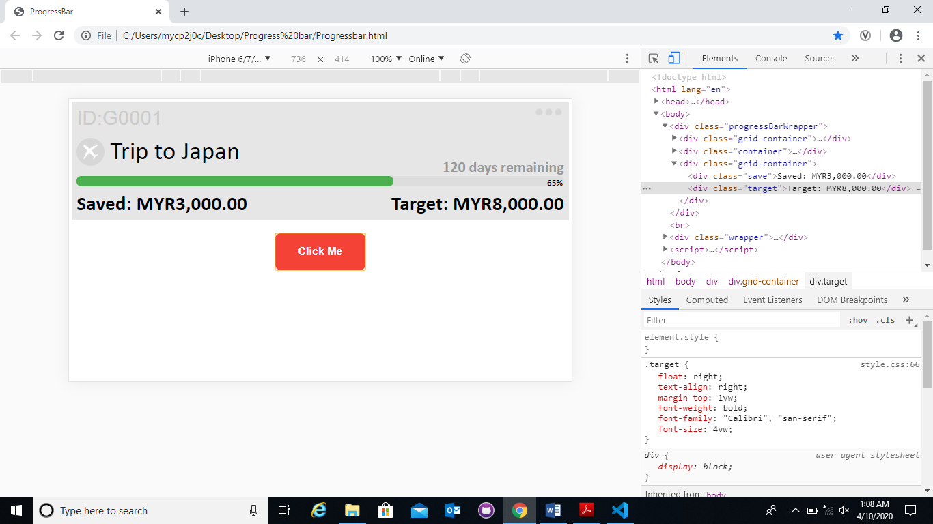

Step 4: Create JavaScript code for get function of move the Progress bar and show the percentage of the progress bar range. I create a button for the progress bar to function.

**Technical Report 2.**

This is a points and reward showing display pages. I was assigned to do the UI/UX development for this pages. Technically, I used Visual studio code platform and Code it in HTML, CSS and JavaScript.

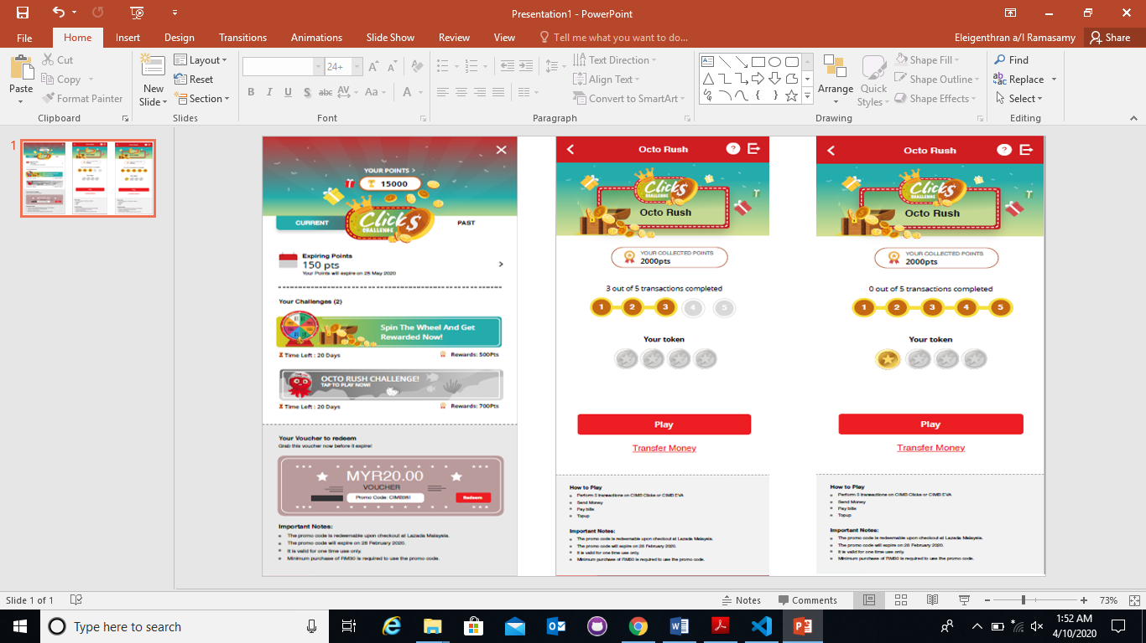

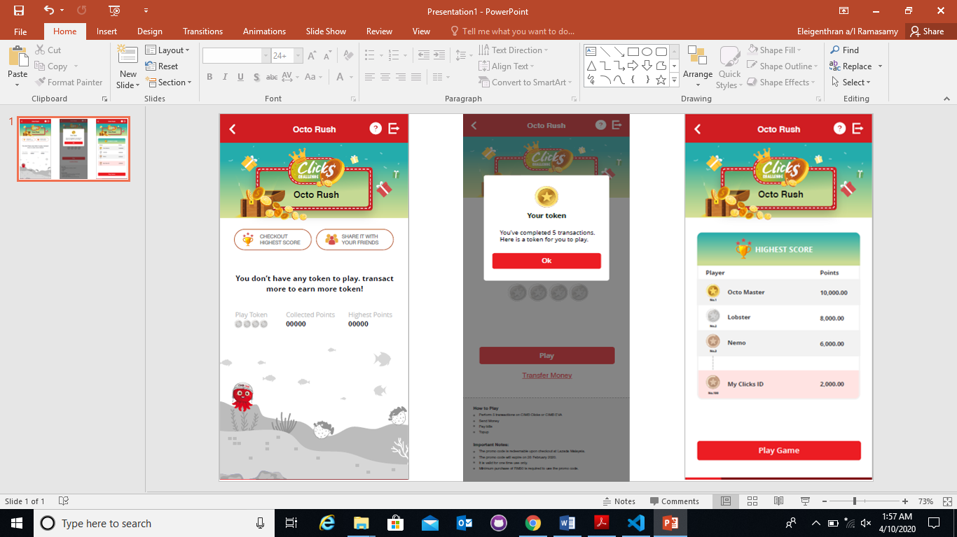

Step 1: Refer the pdf files and understand the flow to develop the UI/UX design.

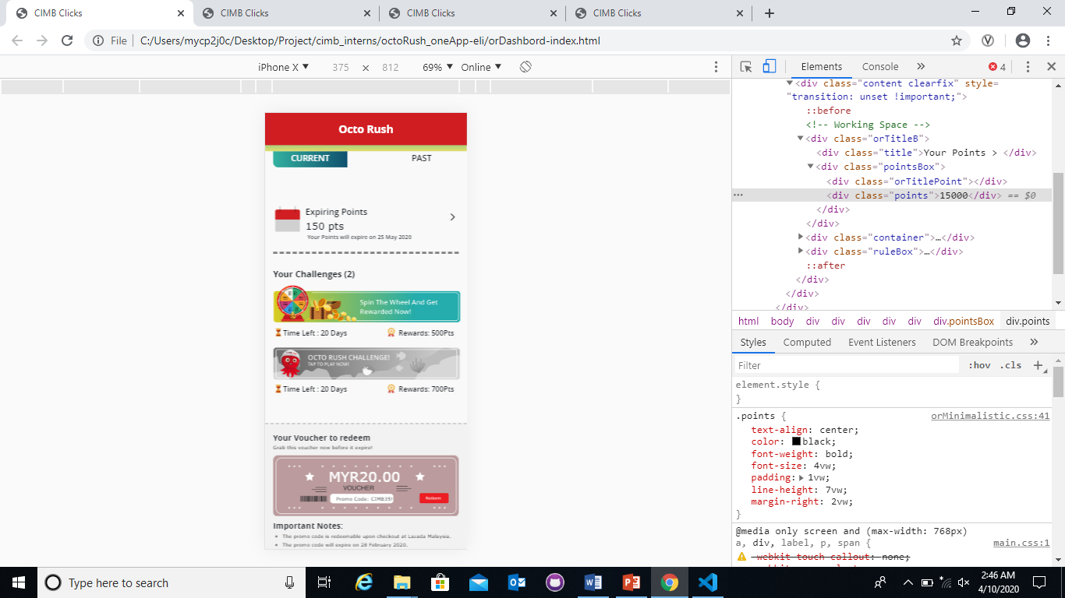

Step 2: Create containers for elements > Code the elements in HTML & CSS > Align the Icons and banners > Set the texts using position absolute > Finally, Check the Pdf UI and code developed page look exact same.

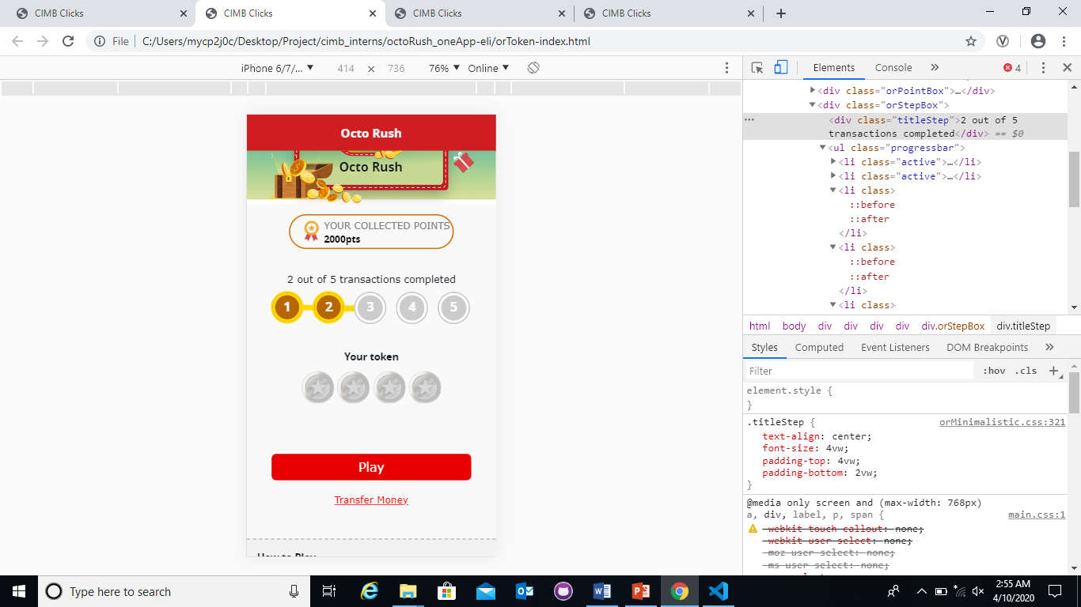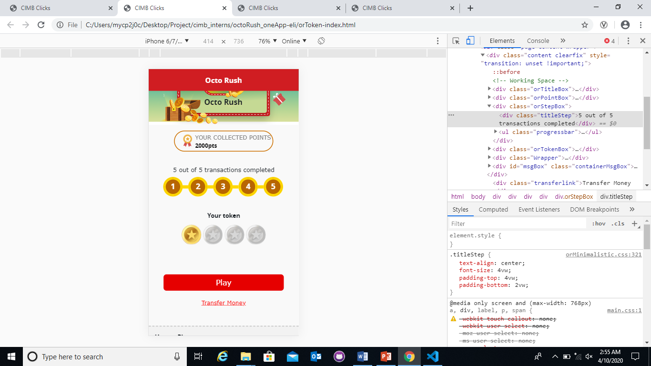

Step 3: Start code for the second page > Create containers for elements > Code for the elements in HTML & CSS > Code for the step progress bar > color it for active after & before.

Step 4: Set the token icon inline and give them different classes and style the classes in CSS > We can change the classes for get the token to in gold or grey.

Step 5: Code the button, link and rules in below the page in Basic HTML and CSS > Finally, Check the Pdf UI and code developed page look exact same.

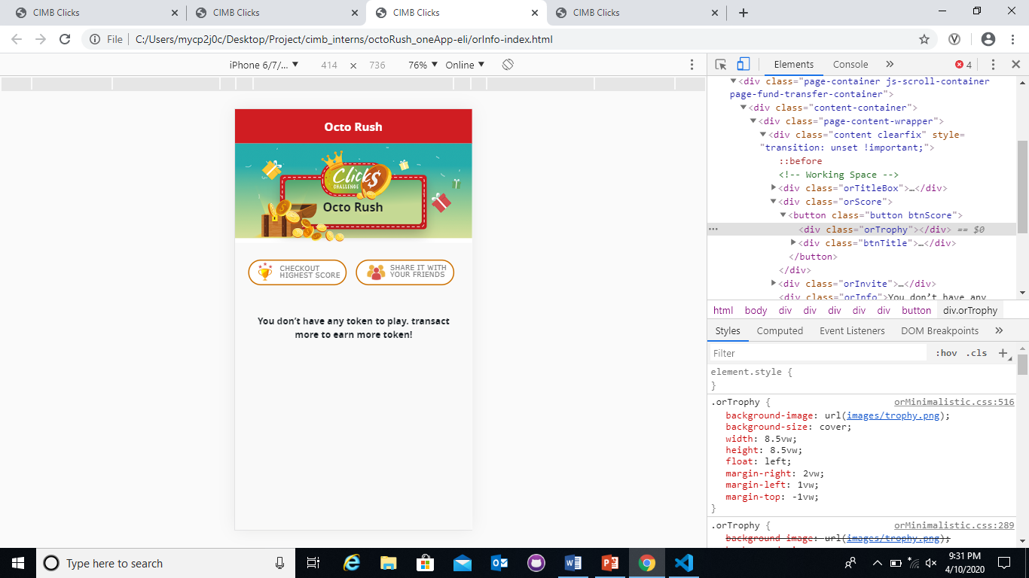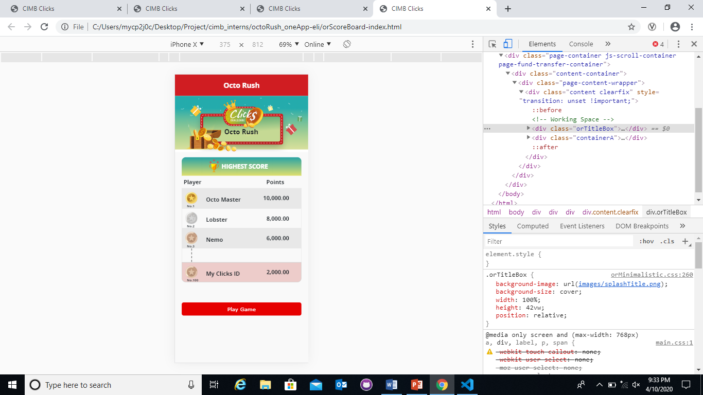

Step 8: Start code for the following page > Set the header banner > Code the elements > Create a class name for the Info to show up there > Style the elements using CSS > Finally, Check the Pdf UI and code developed page look exact same.

Step 9: Code for the last page > Create the table using div > Code the elements using position Absolute for them to fix in look like table > Style it using CSS > Finally, Check the Pdf UI and code developed page look exact same.

**Technical Report 3.**

This is a e-statement record display pages in mobile app. I was assigned to do the UI/UX development for this pages. Technically, Senior developers gave me the exist web code elements like CSS file and existing classes in the code file. Then, I used Visual studio code platform and Code it in HTML and CSS.

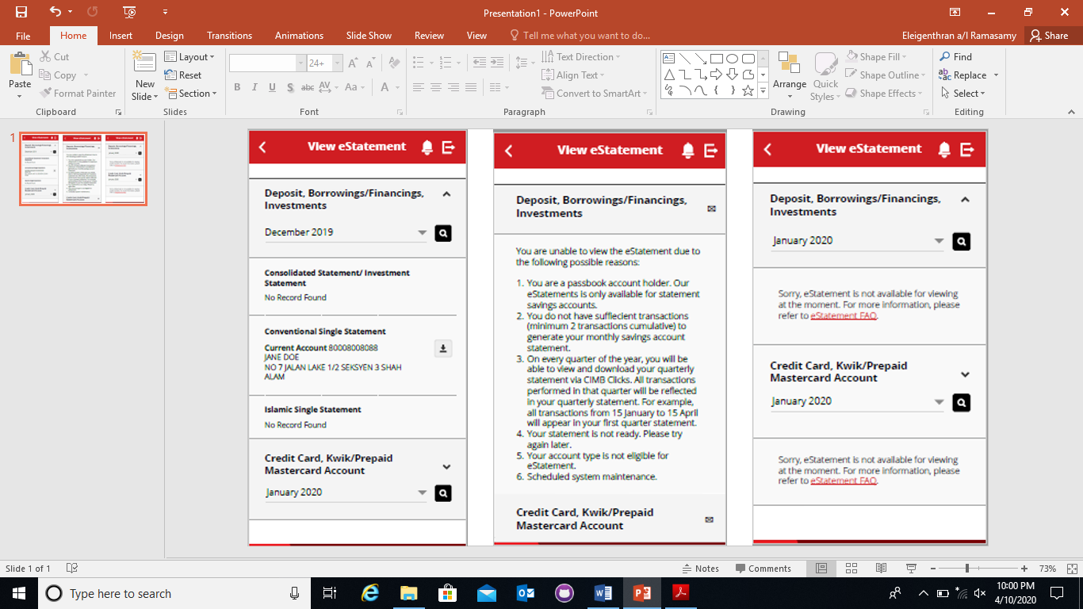

Step 1: Refer the pdf files and understand the flow to develop the UI/UX design.

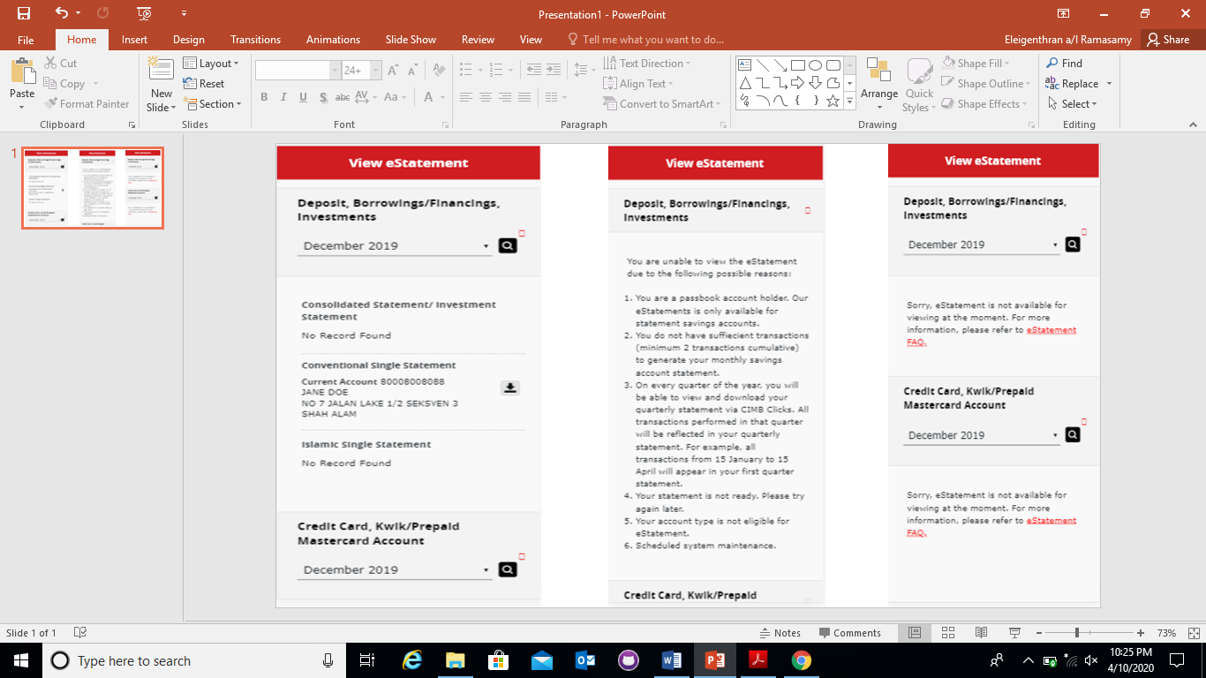

Step 2: Refer the existing code > Write down things need to do and adjust for mobile app.

Step 3: Follow the existing classses and start the UI/UX development.

Step 4: Do the CSS code inline > Set the icons and texts.

Step 5: Finally, Check the Pdf UI and code developed page look exact same.